Ilie Dumitru & Neculae Andrei-Fabian

Grupa 152

Make video games. Revolutionize the world

Hello and welcome to our presentation, we are Ilie Dumitru and Neculae Andrei-Fabian and we want to present some of the games and toys that changed the world.

Our objective today is to show the greatness of video games and why they are so important nowadays. Sure, some people may call them a waste of time, but we believe life isn’t just about work, it’s also about having fun, and video games are an awesome way of doing just that. Furthermore, besides the fun aspect, they also helped with the discovery of benefic and helpful things for out society.

Thus, we will begin by watching how the infamous Rubik's Cube became a tool for understanding group theory, a branch of math with many aplications in almost every field. We shall also talk about some of the most revolutionizing algorithms introduced in the video game industry, the “Fast inverse square root” and the “Binary space partiton”, both of which are used to this very day in computer generated images (known as CGI) for movies and light transport optimisation.

Last but not least, we shall discuss about how one of the best selling game of all time, Minecraft, is used by the Block by Block foundation to give essential power to change the comunity to those who otherwise would have no power or influence in such manners.

The presentation will be very short and dense, only about 20 minutes and we encourage asking questions when they appear. Without any further ado, let's begin.

Top Gun Assignment

Answer and discuss the following questions / themes / issues. Illustrate with scene descriptions / explanations and quotations / lines from the movie.

1) Top Gun leadership – Commanders’ / Superiors / Instructors’ types and styles

(from hysteria to authority and mentorship, from yelling to inspiration)

Consider Cmdr. Stinger, Viper;

Instructors Jester, Charlie etc.

Answer :

Cmdr. Tom “Stinger” Jardian is a former Top Gun graduate and currenly the commanding officer of the Top Gun school. He is very strict when is comes to following the rules his leadership style can be considered tough. He has very high expectations for his students.

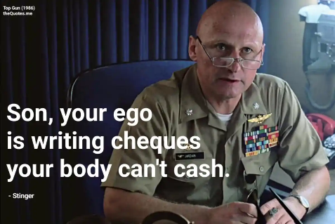

Cmdr. Mike “Viper” Metcalf is a former fighter pilot, the first one who won the Top Gun trophy, and also the senior instructor at the Top Gun school. He is very supportive towards the students, helping them overcome their problems. He is very calm and his collected leadership style inspires his students to reach their full potential.

Instructor Charlotte "Charlie" Blackwood is an expert when it comes to air combat tactics. Her intelligence and her quick and on point analysis capacity make her a very likeable character. She is also very supportive towards Maverick during his hard times.

Instructor Rick “Jester” is usually silent and vigilent, doing his best at his job.

2) The fighter pilots’ missions and adventures in the air – the photo of the inverted MIG, the Cougar situation, the tragic accident, the dogfighting, the rescue mission at the end etc.

Consider this:

Maverick breaks rules, sure, but he’s also able to think outside the box. Sometimes, bending the rules is the only way to push the envelope and take things to the next level.

Do you agree? Illustrate with situations / scenes from the film – point out Mav’s actions/reasons/style significance

Answer :

Despite his tendancy of breaking rules, Maverick proves himself to be among the best pilots. His out of the box thinking helped him get out dangerous situations or even save the other pilots. He also managed to discover something that wasn’t known at that point about MIG’s because of his stunt. By breaking the rules, he managed to save Cougar during when he froze and almost ran out of gas. In my opinion, Goose’s death was far from being Maverick’s fault and there really isn’t anything to reproach, it was just a tragic accident.

What is the root of his at times reckless behavior / actions?

Answer :

Maverick’s father was just as reckless as he is, but he also managed to do the right and most important thing – saving people. Thus, his father’s legacy definetely left a mark on Maverick, who now wants to prove not only that he can do what his father did, but also that he can do it better.

3) The relationships between comrade pilots, especially Mav - Goose, Mav - Iceman (from rivalry and sarcasm to respect and genuine understanding / support / cooperation). Exemplify with scenes and lines.

Also point out Iceman’s criticisms of Maverick’s actions and behavior.

Answer :

Easily the best relationship in the movie, Mav-Goose is a fine example of good writing. Maverick lost both his parents when he was little, and Goose was the only “family” he had left. He cherished Goose as much as he cherishes being a pilot, which obviously means a lot. The same can also be said about Goose, who, despite the moments when Maverick was breaking rules, possibly putting them both in danger, loved flying with his friend, understanding him and his actions better than anyone else.

Even if Mav and Iceman started on cold terms, being sarcastic and not losing any chance of mocking each other, in the end they start to respect each other. Iceman is very critic when it comes to Maverick’s actions, considering him to be a danger for himself and for the other pilots. Being rivals and also good pilots obviously made them understand each other better, as their flying skills spoke louder than any of them could. Goose’s death strengthen their relationship, as Iceman starts feeling bad for Maverick, while the later got over his pride and congratulated Iceman for getting the Top Gun trophy, marking the moment when their rivalry ends and their friendship begins.

To what extent do you agree (or not)?

Answer :

While I agree with Iceman’s behavior towards Maverick considering he wants to make the rule-breaking pilot to understand the extent and risk of his actions, I also think Iceman should at least try to see and reflex upon Maverick’s point of view before starting the criticism.

The pilots at Top Gun are pretty much one big family. They compete like brothers would, they fight like brothers would, but at the end of the day, as Viper reminds them, they're all on the same team.

Chew on This

Take a peek at these thesis statements. Agree or disagree?

Family isn’t only about blood. Groups of people that are on the same team, that eat, sleep, and live together, and work together towards a common goal (like the pilots at Top Gun) can be just as strong as a family.

Family determines who we are. Maverick for example, is a lot like the father he lost when he was still just a little boy.

Answer :

The movie is a good example of why family isn’t only about blood. The people who make us feel safe, help us improve ourselves, get happy for us or angry on our behalf are what a family is really about. The blood family is the family we don’t get to choose, but it is obviously not the only family one can have. Some friendships, along with the strong bonds that come with them, are so strong that they can define what a family means better than any relative will ever be able to.

4) Discuss the significance of the scene where Maverick is driving his motorcycle on the freeway and sees the plane in the sky.

How many times do we see this scene? Before what? After what? Place it in time.

Where was Maverick heading? What was he leaving behind, where had he been before?

What do you think he was feeling when seeing the plane above his head?

Answer :

We see Maverick driving his motorcycle on the freeway three times during the movie. The first time it was before the dinner at Charlie’s house, after the volleyball match with the other pilots. The second one was after Maverick took the gamble and got the right answer during the air combat class. He started driving his motorcycle while pretending not to hear Charlie, making her chase after him, trying to explain how she doesn’t want anyone from the class to know she fell for him during an heartwarming confession.

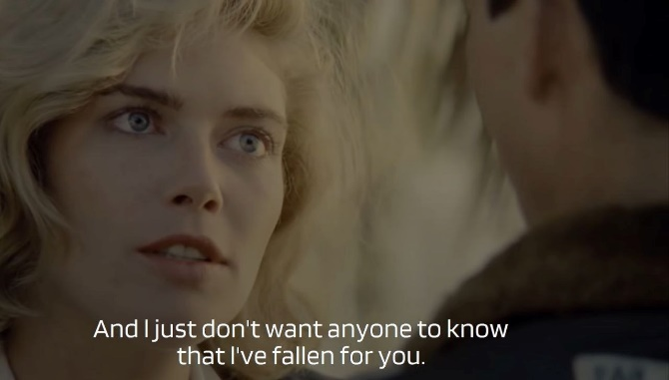

The third and last time was soon after Goose’s death, which affected Maverick a lot. During this scene, he saw a plane above his head, which, on one hand, made him remember the thing he loves more than anything, being a pilot, while, on the other hand, reminded him of his best friend’s death. However, he managed to gain the courage, allowing Maverick to finally move on.

5) 10-15 Aviation / military terms/phrases and word/expressions

Answer:

1. Dogfighting = lupta la mare viteza intre mai multi oponenti
2. Wingman = copilot
3. Lieutenant = locotenent
4. Flyby = zbor la altitudine mica
5. Security clearance = statut ce permite accesul la informatie clasificata
6. Runway = pista de decolare
7. Diamond = avion foarte scump (in contextul filmului)
8. Mayday = procedura de urgenta
9. Bogies = avioane (neidentificate) considerate ostile
10. Hard deck = limita de siguranta (1000 feet)

6) 10 General English expressions

Answer :

1. A run for your money = provocare
2. Crash and brun = a esua la ceva (in contextul filmului, in dragoste)
3. Bugging out = a se retrage
4. Bull’s Eye = centrul tintei (mai ales la tirul cu arcul)
5. To let it go = a lasa trecutul in urma (legat de moartea lui Goose)
6. Larger than life = ceva de proportii imense
7. Roger = mesajul a fost receptionat
8. To be on vapour = a fi pe rezerva
9. Wild card = imprevizibil
10. Lost the edge = s-a pierdut abilitatea, convingerea